

CS342 Operating Systems

Homework 2

Ata Seren

21901575

Section-2

1. 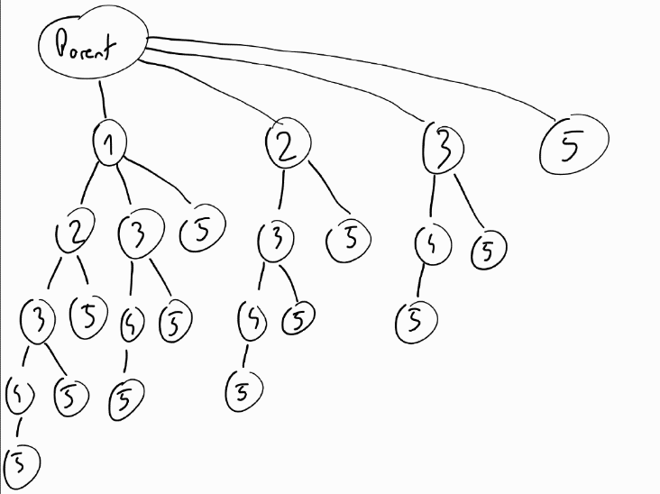

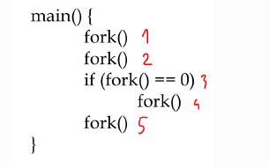

I gave a number to each fork() to name the process they create on the tree to follow them easily. 23 child processes have been created according to the tree.

If we consider the parent process too, 24 process have been created in total.

1. Speedup <= $\frac{1}{S+\left(\frac{1-S}{N}\right)}$ which N = number of processing cores

When N = 8, $\frac{1}{S+\left(\frac{1-S}{8}\right)}=4$. According to this, S = 1/7

When N = 16, $\frac{1}{\frac{1}{7}+\left(\frac{1-\frac{1}{7}}{16}\right)}=\frac{56}{11}≅5.09$

Speedup <= 5.09

1. One 10, one 20, one 30 and two 50 will be printed. Their order can change if parent is processed faster than child or vice versa.

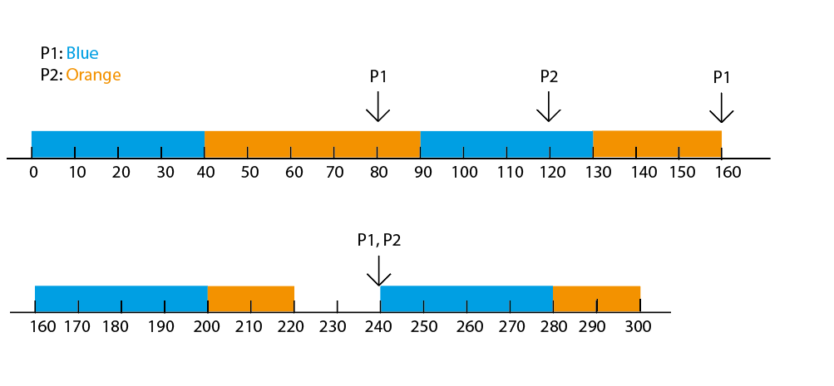

For FCFS:

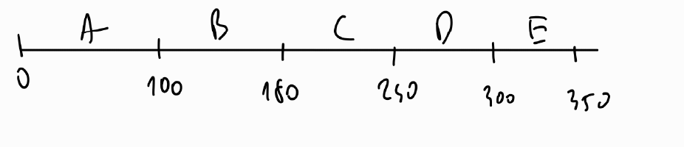

|  |  |  |  |  |  |
| --- | --- | --- | --- | --- | --- |
|  | Arrival | CPU Burst | Finish | Turnaround | Waiting |
| A | 0 | 100 | 100 | 100 | 0 |
| B | 15 | 80 | 180 | 165 | 85 |
| C | 30 | 60 | 240 | 210 | 150 |
| D | 35 | 60 | 300 | 265 | 205 |
| E | 45 | 50 | 350 | 305 | 255 |

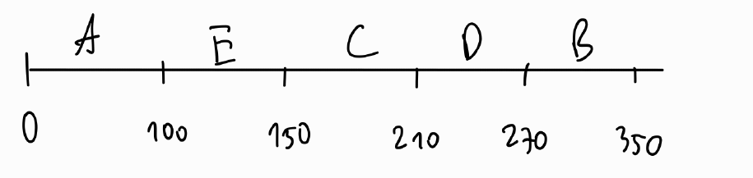 For SJF:

|  |  |  |  |  |  |
| --- | --- | --- | --- | --- | --- |
|  | Arrival | CPU Burst | Finish | Turnaround | Waiting |
| A | 0 | 100 | 100 | 100 | 0 |
| B | 15 | 80 | 350 | 335 | 255 |
| C | 30 | 60 | 210 | 180 | 120 |
| D | 35 | 60 | 270 | 235 | 175 |
| E | 45 | 50 | 150 | 105 | 55 |

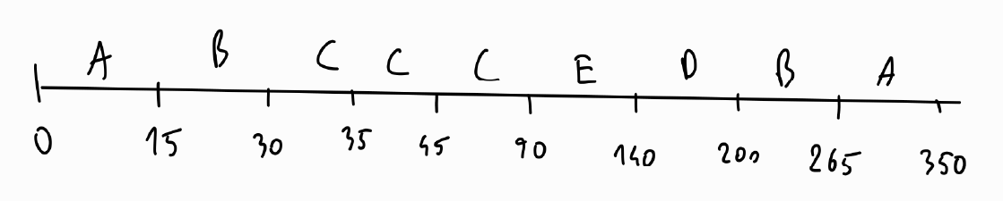 For SRTF:

|  |  |  |  |  |  |
| --- | --- | --- | --- | --- | --- |
|  | Arrival | CPU Burst | Finish | Turnaround | Waiting |
| A | 0 | 100 | 350 | 350 | 250 |
| B | 15 | 80 | 265 | 250 | 170 |
| C | 30 | 60 | 90 | 60 | 0 |
| D | 35 | 60 | 200 | 165 | 105 |
| E | 45 | 50 | 140 | 95 | 45 |

For RR(q = 20):

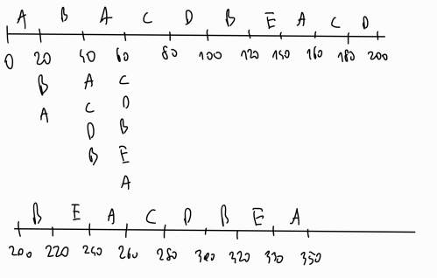

|  |  |  |  |  |  |
| --- | --- | --- | --- | --- | --- |
|  | Arrival | CPU Burst | Finish | Turnaround | Waiting |
| A | 0 | 100 | 350 | 350 | 250 |
| B | 15 | 80 | 320 | 305 | 225 |
| C | 30 | 60 | 280 | 250 | 190 |
| D | 35 | 60 | 300 | 265 | 205 |
| E | 45 | 50 | 330 | 285 | 235 |

For preemptive priority scheduling with RR(q=20) applied on equal

priority:

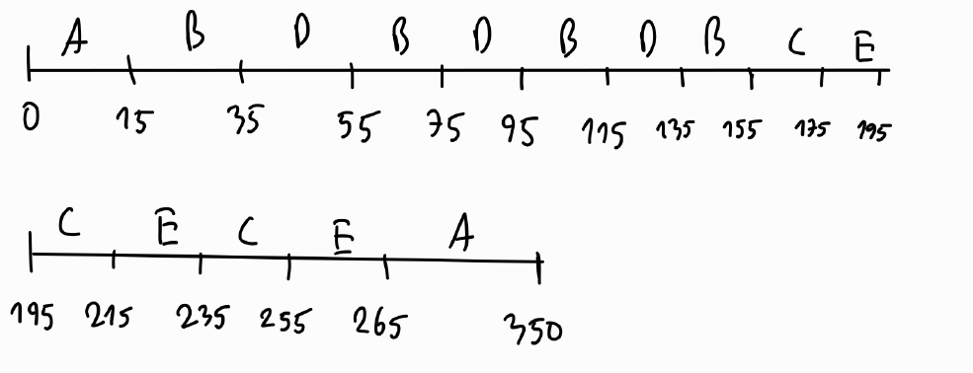

|  |  |  |  |  |  |
| --- | --- | --- | --- | --- | --- |
|  | Arrival | CPU Burst | Finish | Turnaround | Waiting |
| A | 0 | 100 | 350 | 350 | 250 |
| B | 15 | 80 | 155 | 140 | 60 |
| C | 30 | 60 | 255 | 225 | 165 |
| D | 35 | 60 | 135 | 100 | 40 |
| E | 45 | 50 | 265 | 220 | 170 |

1. For process A:

Τn+1 = α * tn + (1 – α) * Τn

α = 0.8 T0 = 10 ms

Τ1 = 0.8 * 20+ 0.2 * 10 = 18

Τ2 = 0.8 * 10+ 0.2 * 18 = 11.6

Τ3 = 0.8 * 40+ 0.2 * 11.6 = 34.32

Τ4 = 0.8 * 30+ 0.2 * 34.32 = 30.864

Τ5 = 0.8 * 20+ 0.2 * 30.864 = 22.1728

Predicted value for process A after the mentioned bursts were executed is 22.1728 ms.

For process B:

Τ1 = 0.8 * 30+ 0.2 * 10 = 26

Τ2 = 0.8 * 20+ 0.2 * 26 = 21.2

Τ3 = 0.8 * 40+ 0.2 * 21.2 = 36.24

Τ4 = 0.8 * 10+ 0.2 * 36.24= 15.248

Predicted value for process B after the mentioned bursts were executed is 15.248 ms.

If process A and B have arrived at the same time or in the queue at the same time, B will be picked because its predicated CPU burst time is less than A’s.

1. Function that will be run by the thread will print 1000 which is value of x after initialized and incremented in the function, 2200 which is value of global variable y and 300 which is value of z transferred to the function as an argument during thread creation.

In main(), 100 which is value of global variable x, 2200 which is value of global variable y and 300 which is value of global variable z are printed.

Output:

1000 2200 300

100 2200 300